Enterprise Software Platforms

HW#5 - Framework

**Team (Technocrats)**

Vijaylaxmi Nagurkar

Monica Dommaraju

Sruthi Chilukuri

Geethu Padachery

Table Of Contents

**Steps followed to complete Sections 1-5** **3**

1.Download & Install ServiceMix 3

2. Starting Apache ServiceMix 4

3. Apache ServiceMix console 5

4. Using Camel 7

5. Adding ActiveMQ to the Mix 9

**ActiveMQ JMS application** **10**

**Github Source code for ActiveMQ** **13**

# Steps followed to complete Sections 1-5

## 1.Download & Install ServiceMix

* Service mix folder screenshot

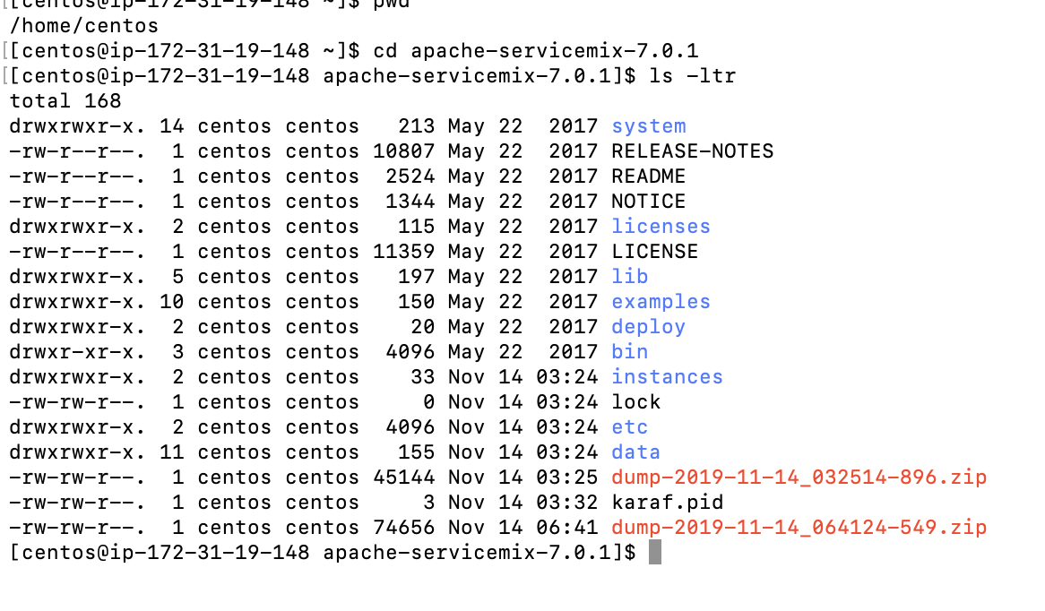

* Install Java and set JAVA_HOME

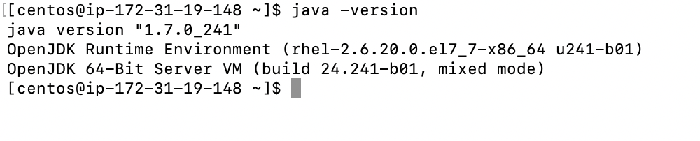

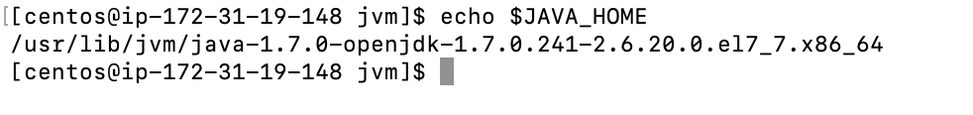

## 2. Starting Apache ServiceMix

* Run the following commands:

$ cd ~/Applications/apache-servicemix-7.0.0-SNAPSHOT

$ ./bin/servicemix

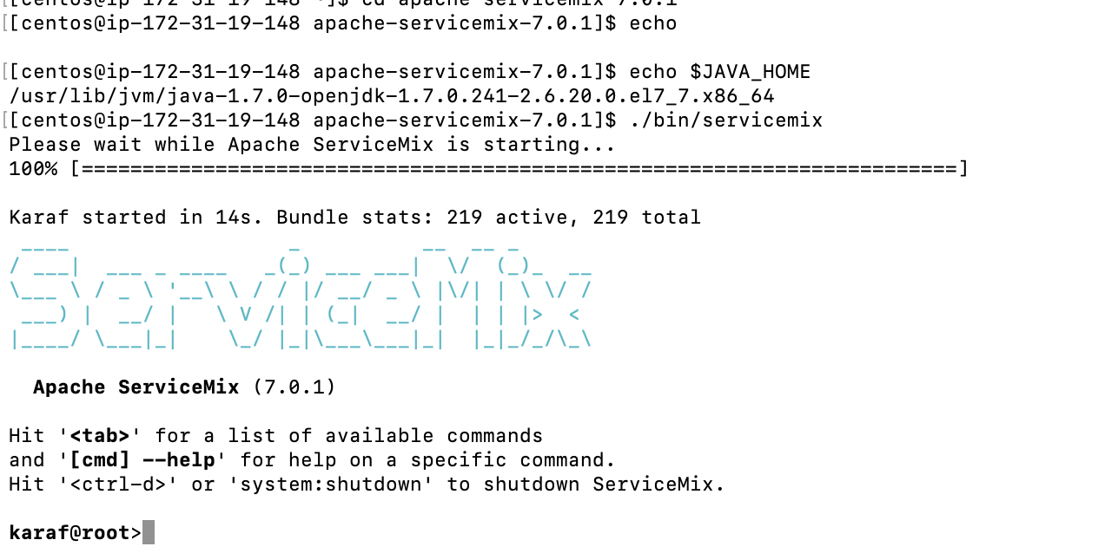

# 

## 3. Apache ServiceMix console

3.1 Working with Bundles

Bundle:list

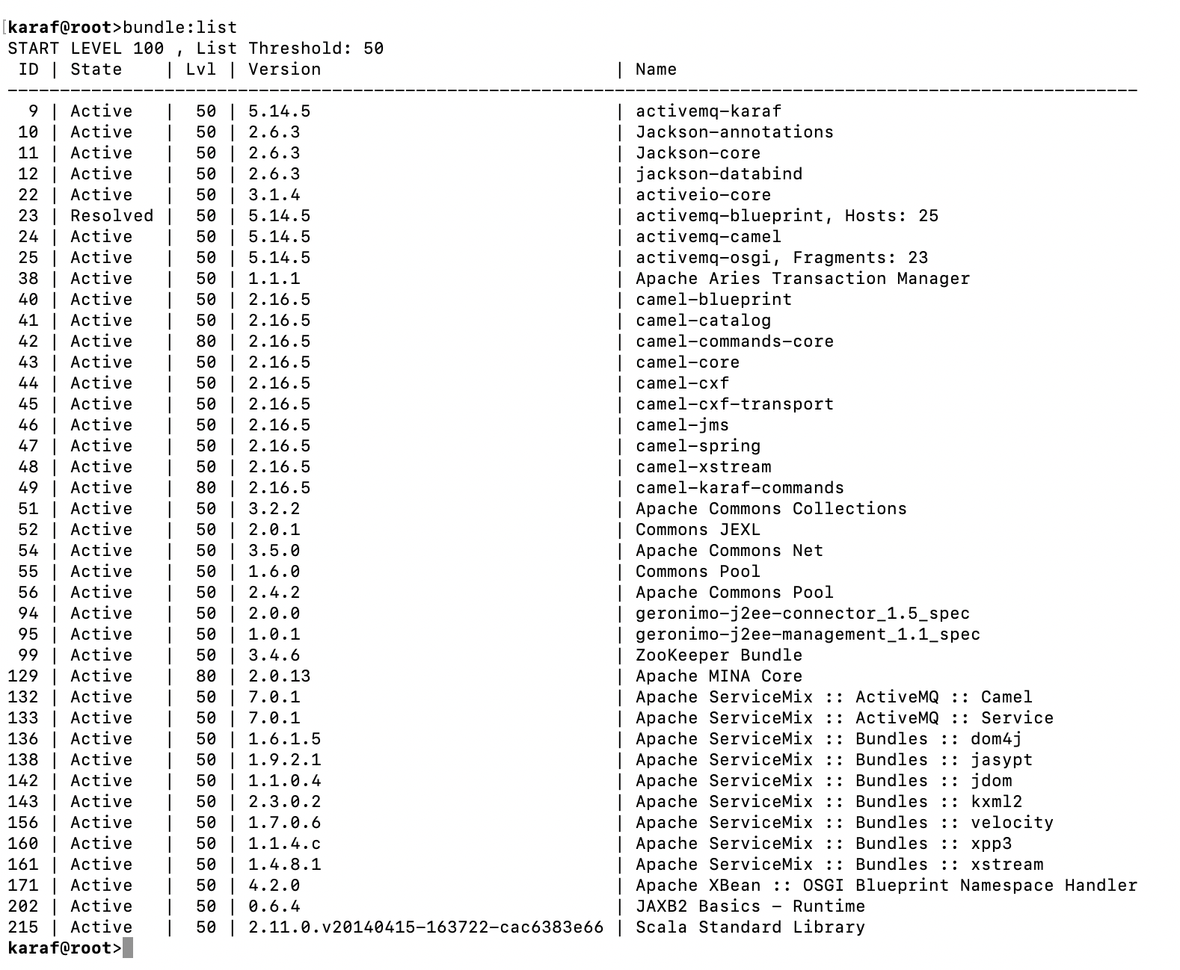

3.2 Working with logging

Log:display

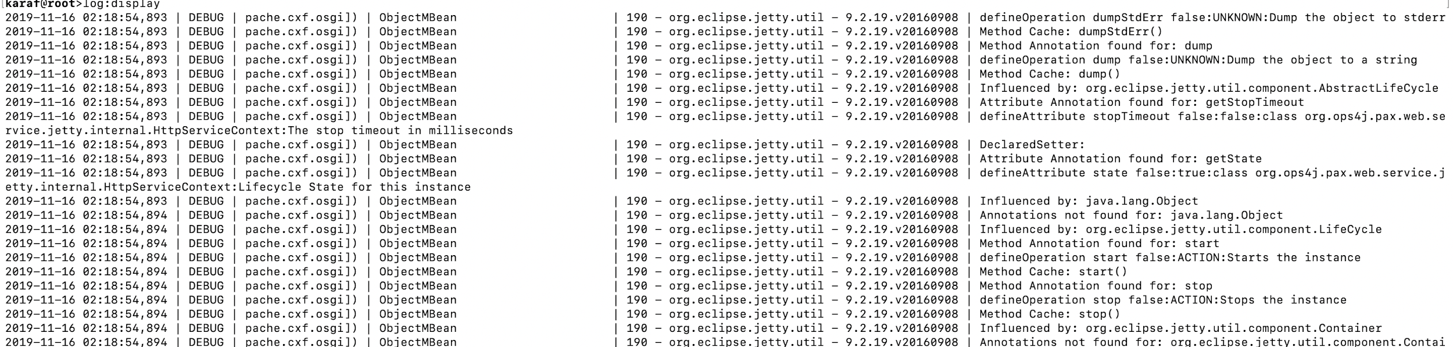

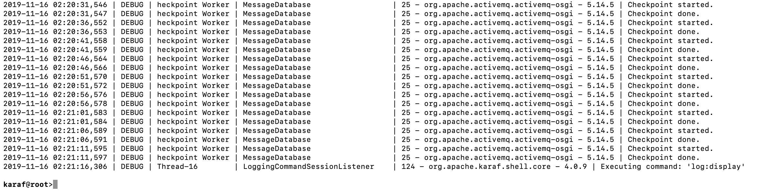

log:set DEBUG

log:display | grep DEBUG

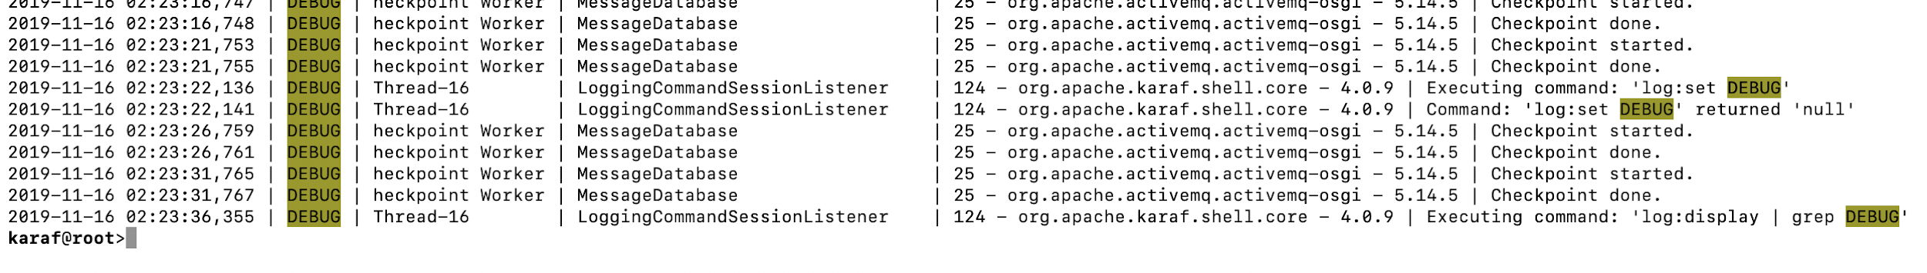

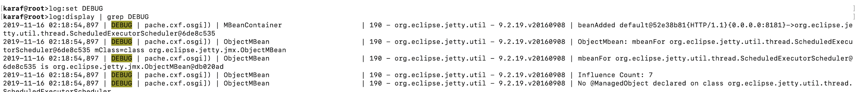

## 4. Using Camel

* Creating the route

Create testfile.xml under ServiceMix's deploy directory

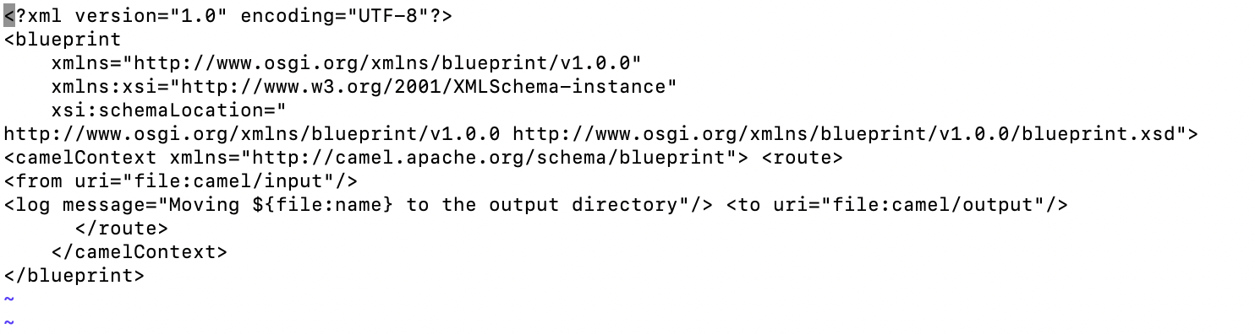

* Deploying the route

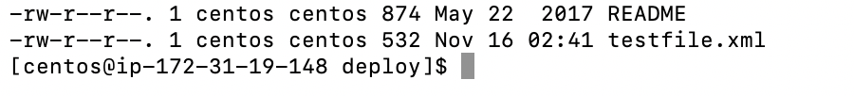

* camel/ input folder appears in ServiceMix installation directory:

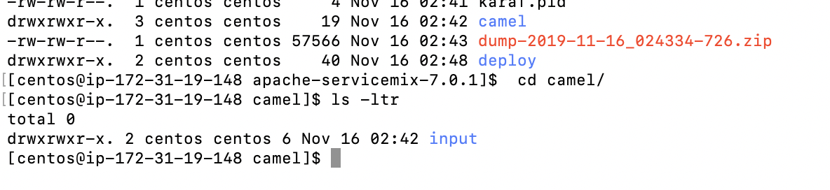

* log:display|grep testfile



* Using the shell to manage the route

Bundle:list

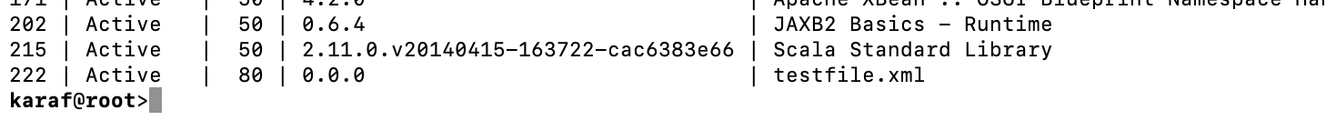

Bundle:stop 222



Bundle:start 222



## 

## 5. Adding ActiveMQ to the Mix

* Moving files and sending event messages

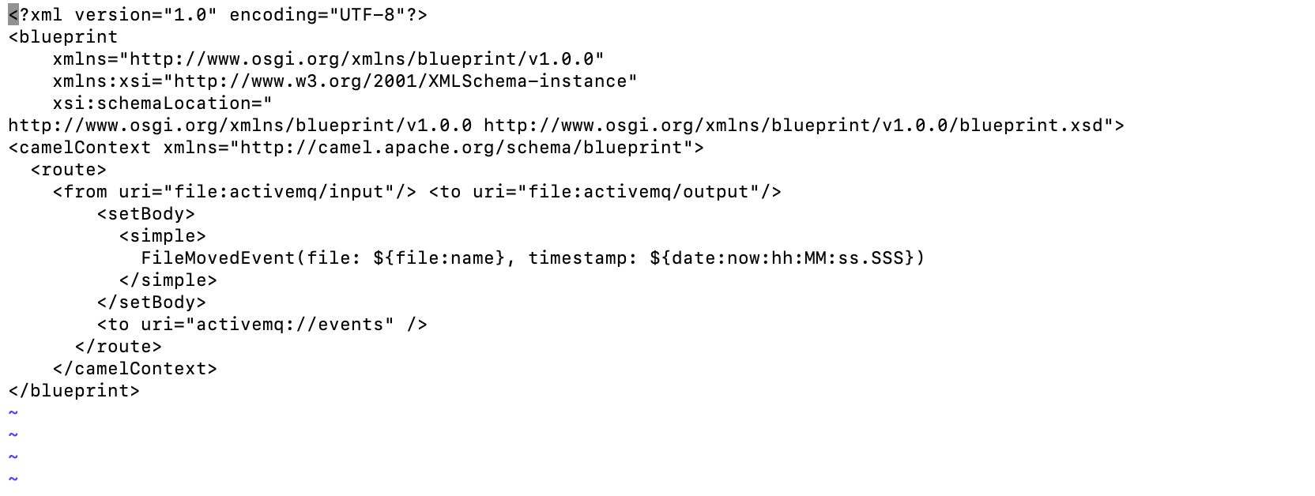



* Receiving the event messages

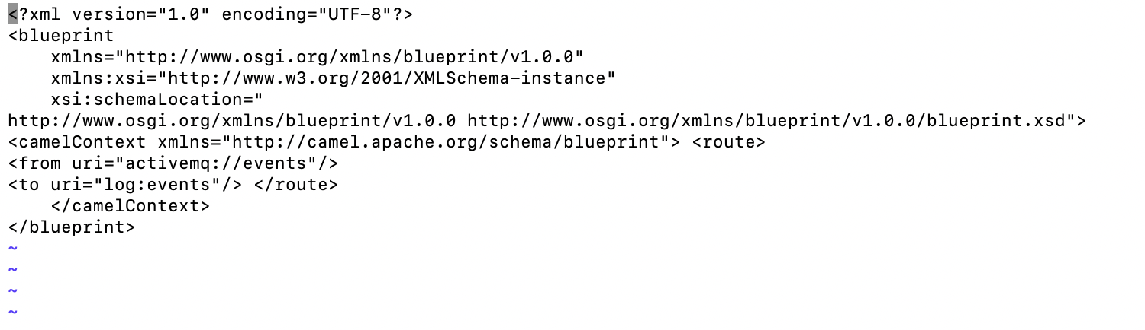



* Using the shell to manage the routes



Bundle :stop 224



Bundle start:224



# ActiveMQ JMS application

1. Installing ActiveMQ on local machine using brew

|  |
| --- |
| $ brew install apache-activemq ==> Downloading https://www.apache.org/dyn/closer.cgi?path=/activemq/5.15.10/apache-activemq-5.15.10-bin.tar.gz ==> Downloading from http://mirrors.gigenet.com/apache/activemq/5.15.10/apache-activemq-5.15.10-bin.tar.gz ######################################################################## 100.0% ==> Caveats To have launchd start activemq now and restart at login:  brew services start activemq Or, if you don't want/need a background service you can just run:  activemq start ==> Summary 🍺 /usr/local/Cellar/activemq/5.15.10: 559 files, 68MB, built in 19 seconds |

1. Then start **activemq** as shown below. ActiveMq by default listens on port **61616**.

|  |
| --- |
| $ activemq start INFO: Loading '/usr/local/Cellar/activemq/5.15.10/libexec//bin/env' INFO: Using java '/Library/Java/JavaVirtualMachines/jdk1.8.0_172.jdk/Contents/Home/bin/java' INFO: Starting - inspect logfiles specified in logging.properties and log4j.properties to get details INFO: pidfile created : '/usr/local/Cellar/activemq/5.15.10/libexec//data/activemq.pid' (pid '42253') |

1. Create a new Maven project and download the activemq dependency as shown below

|  |
| --- |
| <?xml version="1.0" encoding="UTF-8"?> <**project** xmlns="http://maven.apache.org/POM/4.0.0"  xmlns:xsi="http://www.w3.org/2001/XMLSchema-instance"  xsi:schemaLocation="<http://maven.apache.org/POM/4.0.0> http://maven.apache.org/xsd/maven-4.0.0.xsd">  <**modelVersion**>4.0.0</**modelVersion**>   <**groupId**>com.sjsu.technocrats</**groupId**>  <**artifactId**>activemq</**artifactId**>  <**version**>1.0-SNAPSHOT</**version**>   <**dependencies**>  <**dependency**>  <**groupId**>org.apache.activemq</**groupId**>  <**artifactId**>activemq-all</**artifactId**>  <**version**>5.15.10</**version**>  </**dependency**>  </**dependencies**>  </**project**> |

1. ActiveMQ Test results

|  |
| --- |
| Sent message: 935149435 : Thread-0 Sent message: 1175252952 : Thread-1 Received: Hello world! From: Thread-39 : 192038876 Sent message: 223072797 : Thread-2 Received: Hello world! From: Thread-37 : 1497513497 Received: Hello world! From: Thread-35 : 1455958848 Received: Hello world! From: Thread-31 : 444599044 Sent message: 1629264905 : Thread-11 Received: Hello world! From: Thread-40 : 419503465 Sent message: 915175947 : Thread-15 Sent message: 1313504345 : Thread-18 Sent message: 515291904 : Thread-12 Received: Hello world! From: Thread-18 : 1461371500 Sent message: 2008082244 : Thread-10 Sent message: 2128659770 : Thread-13 Received: Hello world! From: Thread-1 : 1899469428 Received: Hello world! From: Thread-12 : 445201545 Received: Hello world! From: Thread-0 : 1631867750 Received: Hello world! From: Thread-11 : 1876656002 Sent message: 1729125671 : Thread-28 Sent message: 788670745 : Thread-30 Sent message: 381950365 : Thread-23 Received: Hello world! From: Thread-2 : 671679513 Received: Hello world! From: Thread-15 : 850655365 Received: Hello world! From: Thread-10 : 2037843482 Sent message: 294420891 : Thread-29 Sent message: 2022859509 : Thread-31 Received: Hello world! From: Thread-23 : 402912493 Received: Hello world! From: Thread-13 : 2061459129 Sent message: 1672105646 : Thread-38 Sent message: 1906777097 : Thread-41 Sent message: 1749100796 : Thread-42 Sent message: 95791298 : Thread-36 Sent message: 277718429 : Thread-35 Sent message: 158953662 : Thread-40 Received: Hello world! From: Thread-31 : 1985315407 Sent message: 1818291553 : Thread-43 Sent message: 1073604131 : Thread-46 Sent message: 897930183 : Thread-45 Received: Hello world! From: Thread-46 : 825888372 Received: Hello world! From: Thread-30 : 566612817 Received: Hello world! From: Thread-28 : 1775742573  Process finished with exit code 0 |

1. Queue tab for jms ActiveMQ

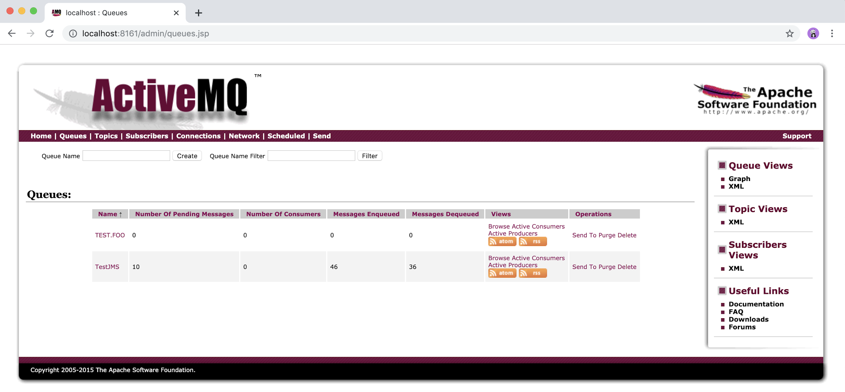

# 

# Github Source code for ActiveMQ

<https://github.com/monicasjsu/JMS>